The Quartet of the Vulnerable, Sermon 4
Eric Lintala

Video:
A Movement of Change - https://vimeo.com/372998036
- At World Relief, We aren’t about short-term fixes to long-term problems, and we don’t want to see just one part of someone’s life transformed. We want to see people in the most vulnerable situations transformed economically, socially, and spiritually in partnership with the local church.
  - In fact, our CEO and President recently came to WNY and shared that our work is only possible through the local church
  - Even if we closed our doors tomorrow, which isn’t going to happen, we would not lose hope because while organizations come and go, governments rise and fall, and nations experience change, the Church remains. The Church has no exit plan.
  - I hope that excites you. God’s primary method of changing the world is the church.
- This is one of the primary reasons why it is so important for us to gather together each week, to worship our savior, to learn, to strengthen and encourage each other, and to be sent back out to live as the diasporic, the dispersed church, proclaiming the good news of Jesus in word and deed in our communities.

Overview:
- This is why our series goals matter:
  - To orient our eyes and hearts towards God’s heart for the hurt and suffering
  - To show how God works in and through the most vulnerable
  - To challenge and encourage us to emulate Christ in our lives
- As our hearts become more like God’s, as we understand more fully how he is at work in the world, we will grow as the church and live more like Christ.
- Guiding Passage:
  - Zechariah 7:9-10 – “This is what the Lord Almighty said: ‘Administer true justice; show mercy and compassion to one another. Do not oppress the widow or the fatherless, the foreigner or the poor. Do not plot evil against each other.’
- Today, we’re going to talk about the last of these groups, “the Poor,” and then discuss practical next steps for each of us as we leave here today.

Transition:
- When I say, “the poor,” what do you think?
- Are there any Bible passages that come to mind? Maybe you are thinking about:
  - Ruth
  - The Good Samaritan
  - The poor woman who gave all the money she had
  - The Rich Man and Lazarus
  - The woman experiencing bleeding for 12 years
  - The early church selling property and distributing the money
  - Or passages in 1 John or James or Revelation
- Maybe none of those passages came to your mind. That’s fine.
- The point is that God cares about the poor, Jesus lived among the poor, and the Holy Spirit ignited the early church’s passion to be with the poor. You can’t miss it when you read scripture. Open up any page in the Bible and you will likely see something about the poor or poverty.
  - “The poor” are mentioned over 2,000 times throughout Scripture!

Transition:
- As much as I would like to, we are not going to walk through each of these passages together.
- Instead, knowing God’s heart for the poor, let’s discuss what we can do to serve the poor around the world and in our own community.

Helping Without Hurting
- African Proverb about a monkey and fish
A typhoon swept through a faraway land and stranded a monkey on a coastal island. The monkey climbed to the top of a secure, protected treetop and waited for the waters to recede. From the safety of his retreat, he spotted a fish swimming against the raging current. It seemed obvious to the monkey that the fish was struggling and in need of assistance. Being kind of heart, the monkey resolved to help the fish.
A tree branch happened to be dangling over the very spot where the fish was struggling. At considerable risk to himself, the monkey climbed far out on the limb, reached down, and snatched the fish from the “threatening” waters. Immediately, he scurried back to the canopy and laid the fish out on dry ground. For a few moments the fish showed excitement but soon settled into a peaceful rest. Joy and satisfaction swelled inside the monkey. He took a risk to help another creature from the storm and was successful.
  - Questions:
    - Were the Monkey’s motives pure?
    - Did the Monkey help the Fish?
- Point: There is a type of helping that hurts
  - We are all the monkey more often than we care to admit
  - This is especially true when we talk about the poor
- When Helping Hurts
- What is poverty? What does it mean to be poor?
- Poverty defined by materially rich vs. materially poor
  - Those living in wealth and security typically speak of poverty in terms of a lack of material things such as food, money, clean water, medicine, housing, etc.
  - People living in poverty typically talk about poverty in terms of shame, inferiority, powerlessness, humiliation, fear, hopelessness, depression, social isolation, and voicelessness
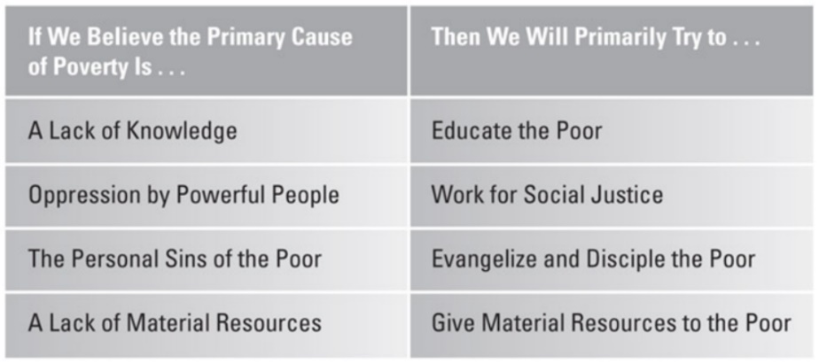
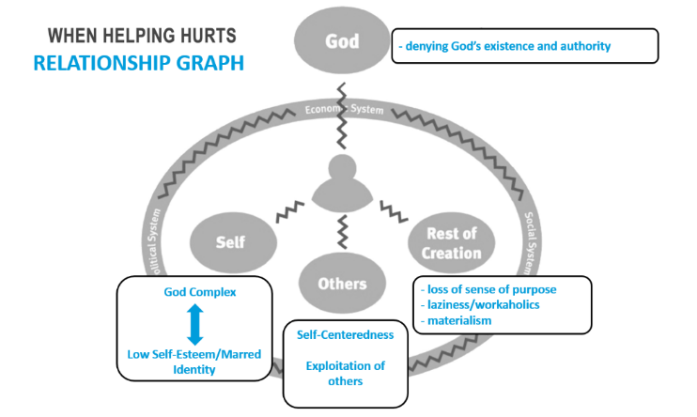
- How we define poverty dictates how we respond to it: (Graphic on page 52)
- Like a doctor treating a patient, “If we treat only the symptoms or if we misdiagnose the underlying problem, we will not improve their situation, and we might actually make their lives worse. And… we might hurt ourselves in the process” (WHH, 52).
- Poverty not as lack of materials, but as broken relationships
- Poverty as broken relationships
  - With God, Rest of Creation, Others, and Self
  - Solution is in the one who brings healing to all of these relationships: Jesus Christ and his death and resurrection
  - So, we are all poor and can thus walk alongside others in our shared poverty
  - We will never see mutually transformative relationships develop until we embrace our mutual brokenness. Until then, “our work with vulnerable people is likely to do far more harm than good.”

Poverty Alleviation
- Poverty alleviation is the ministry of reconciliation: moving people closer to glorifying God by living in right relationship with God, with self, with others, and with the rest of creation” (WHH, 74).
  - As we move towards this reconciliation with those experiencing material poverty, our goal is to help them, “fulfill their callings of glorifying God by working and supporting themselves and their families with the fruit of that work” (WHH, 74).
- Needs to be multi-layered response because poverty is multi-layered
  - All the quartet often at work simultaneously.

Transition
- As we move to the last act of our series on the vulnerable, I want to give each of you a moment to think about what God has been saying to you the last four weeks. Here are some questions that might help you:
  - What is God whispering to me that I’m not hearing?
  - What is the Spirit urging me towards that makes me uncomfortable?
  - Is there anywhere in my life where I am saying, “Yes, But..” to God that needs to be changed to “Yes, God.”
- Pause. Pause.
- In light of everything we have talked about, how should we respond?
- I am not going to answer that question for you. Only you can.
- What I can do is give us a framework for responding. It’s a framework we use at World Relief that is helpful for individuals and groups.

G.A.P.S.
- Simply put, where are the G.A.P.S. that you are called to step into?
- G.A.P.S. is an acronym for “Give. Advocate. Pray. Serve.”
Give:
- We are American Christians. We understand this one.
- Where is your money going?
- If a stranger looked at your bank statement would they see a generous life or a selfish one?
- Are you giving out of your riches or your poverty?
- “If our giving does not at all pinch or hamper us, I should say it is too small. There ought to be things we should like to do and cannot because our commitment to giving excludes them.” – C.S. Lewis
- How about your spending habits?
- The consumption of Americans and Europeans contribute to domestic and international trafficking and exploitation.
- Does what you spend your money on, and where you spend it, lift up the vulnerable or contribute to their oppression?
- Our culture believes that the more stuff we have, the more powerful and meaningful our lives are. This is a lie. Look at the life and teachings of our savior. Possessions are not power, generosity is. (Live Just.ly, 84).
- I’ve already made all of us uncomfortable, so let’s dive into the second category.
Advocate:
- Jenny Yang - “Advocacy is the vehicle that God gives us, that we need to use to speak out when something is wrong.”
- It is speaking into the current reality with the vision of what should be
- Using your voice to lift up those without a voice
  - My goal in this series
  - Speak the truth in your own sphere of influence.
- Where is it in your own sphere of influence that truth needs to be spoken?
- Where are there mistruths and worldviews that are based on something other than Scripture that need to be brought into the light?
- Sign petitions and push for systemic changes to problematic, and broken laws, regulations, and systems
- Use your voice to welcome others and challenge others to think according to God’s call for his people, not anyone else’s.
- Proverbs 31:8-9 – “Speak up for those who cannot speak for themselves, for the rights of all who are destitute. Speak up and judge fairly; defend the rights of the poor and needy.
- Examples of advocates in the Bible:
  - Moses before Pharaoh (Exodus 7)
    - Let my people go!
  - Nehemiah before King Artexerxes (Nehemiah 2)
    - Give me the resources to rebuild Jerusalem
  - John the Baptist before King Herod (Matthew 14)
    - You should not have married your brother’s wife
- You don’t control the outcome. It won’t always be what you want. You might be ostracized, ignored, denied, or even killed.
- Listen to the stories of the vulnerable from their own mouths
- As you grow in relationship with the vulnerable, they will turn from a faceless, voiceless group of people who are all the same, to individuals and friends who you are struggling alongside.
  - Advocacy is the natural byproduct of relationships with the vulnerable.
Pray:
- Best form of advocacy? Prayer
- We get to speak to the creator of the universe.
- Do you know the desires and needs of the oppressed around you enough to pray for them specifically?
- If all of your prayers were answered today, who would benefit?
- Pray for our new neighbors
- Pray for reconciliation of all things and people to God
- Repent of your sins and the sins of your community, country, and world that have contributed to the increasing vulnerability of so many groups of people (WHH, 248).
- Pray for transformation in your own heart and the hearts of those around you
- Pray for the church to rise up as the church in your community, our country, and around the world
- Prayer also changes our own hearts and the hearts of those we pray for
- “Prayer makes your heart bigger, until it is capable of containing the gift of God himself. Prayer begets faith, faith begets love, and love begets service on behalf of the poor” – Mother Teresa (Live Just.ly, 53).
Serve:
- Is your life too busy to serve anywhere? Are you waiting until you retire?
- Where do you spend your time? Where do you need to build margin into your life?
- You don’t need to go alone
  - Walk with friends, family, and neighbors together alongside others
  - Use your relationships as allies in your work
- Start small and start soon
  - Don’t be paralyzed by doing something perfectly or making no mistakes. You will fail. That is okay. Fail forward and with others. Learn. Grow. Fail again.
Transition:
- I get it. This is hard.
- Let me give you a word of encouragement from my time working with hundreds of different volunteers. The hardest step is the first one. This is true when you Give, Advocate, Pray, and Serve.
  - As soon as you give your first dollar, speak out against something that is wrong for the first time, pray a single prayer, or show up and help out the first time, something changes in your heart.
  - It’s almost like you can feel God cheering for you. And Lifespring, that is the most joyful noise that exists in the universe. We were made for this purpose.
- As we follow Christ and give, advocate, pray, and serve generously, we follow the footsteps of the early church

End:
- “Christianity revitalized life in Greco-Roman cities….To cities filled with the homeless and impoverished, Christianity offered charity as well as hope. To cities filled with newcomers and strangers, Christianity offered an immediate basis for attachments. To cities filled with orphans and widows, Christianity provided a new and expanded sense of family. To cities torn by violence and ethnic strife, Christianity offered a new basis for social solidarity. And to cities faced with epidemics, fires, and earthquakes, Christianity offered effective nursing services” – Sociologist Rodney Stark (WHH, 43).
- My heart is for Lifespring Church, the Church in WNY, the American Church, and the global church to follow the word of God and live like the early church.
- We, those of us in this room today and our brothers and sisters meeting throughout Canandaigua right now, are God’s primary method for changing Canandaigua and Ontario County.
- It’s an awesome and beautiful calling. We can’t fulfill this calling alone. We can only do so together, through the life, death, and resurrection of Jesus Christ.
- Would you pray with me?

Communion
Shortly before he was imprisoned and crucified for our sins, Jesus “took bread, and when he had given thanks, he broke it and gave it to his disciples, saying, “Take and eat; this is my body.” Then he took a cup, and when he had given thanks, he gave it to them, saying, “Drink from it, all of you. This is my blood of the covenant, which is poured out for many for the forgiveness of sins. I tell you, I will not drink from this fruit of the vine from now on until that day when I drink it new with you in my Father’s kingdom.” - Matthew 26:26-29

Post-Communion
- It has been a joy to be with you the last four weeks. I am so excited to see where God is leading Lifespring Church.
- I want to leave you with some words shared with a queen who was called to advocate for her people.
- Esther 4:13-14 – “… Do not think that because you are in the king’s house you alone of all the Jews will escape. For if you remain silent at this time, relief and deliverance for the Jews will arise from another place, but you and your father’s family will perish. And who knows but that you have come to your royal position for such a time as this?”
- Lifespring, we have the opportunity today to be God’s hands and feet. If we remain silent, relief and deliverance will arise from another place.
- But, God has called us, each of us in this room, His Church, to be his hands and feet For such a time as this

Benediction
- Please rise and receive this benediction:
May the peace of the Lord Christ go with you: wherever he may send you;
May he guide you through the wilderness: protect you through the storm;
May he bring you home rejoicing: at the wonders he has shown you;
May he bring you home rejoicing: once again into our doors.
Amen.
Go in peace. You are loved.

