Scott Arbeiter sat down with Musee founder and CEO, Leisha Pickering, to talk about Leisha’s new brand, PrettyInside, and her desire to use her company to impact the women who purchase their products and affect change for refugee women and children around the world.

Scott: What was the inspiration for PrettyInside?

Leisha: The story started about nine years ago with the start of Musee. I live in Mississippi. Our state is very poor, and I was looking at my community where many people just need an opportunity for work. I began to think, “What is something I could create or do to help?”

I had the idea of creating an excellent bath product, something that would have a message of hope and love and something that could impact and change our community.

Over the next couple of years, we quickly grew into the largest wholesaler of bath bombs. We began to expand our lines to candles, soaps, salts and other bath products. With this growth we began to look for other opportunities, so I started thinking about skincare.

While in Austin, Texas with my Creative Director, we saw graffiti on the sidewalk that said, #ImSoPretty. Intrigued, we snagged some food truck pasta and sat in my car talking about what beauty is in our culture — how it’s all external and based on how you look.

We wanted to create something different and asked ourselves, “What’s it like to be pretty inside? What is a more holistic view of beauty?” For me, beauty is being strong and kind and courageous. We started thinking about how we could provide not only great skincare, but a great message as well. That was the start of PrettyInside

Scott: What sparked your desire to bless refugee women through your company, and what are you hoping to accomplish in partnership with World Relief?

Leisha: We're just so excited to partner with y'all. This desire was born on a trip to Syria with one of my sons.

We were staying in this beautiful hotel with all the comforts. On the last night of our trip, I ran down to one of the macaroon shops to get some to bring home. It was dark and cold. I remember turning a corner and was startled to see somebody in the shadows.

I looked over and saw a young woman leaning up against a brick wall with a baby in her arms. She couldn't have been more than 22 or 23. Her eyes were closed. It was cold, and she didn't have a blanket. I started to walk past her, but as I got right next to her on the sidewalk she opened her eyes. Our eyes met, and I just stood there.

I went closer to her, knelt down and motioned to ask, “Do you need some water?” She nodded, so I ran back to my hotel. I got the waters out of the refrigerator, grabbed a little travel blanket and then dumped a bowl of tangerines into my bag and went back to her. I felt so helpless because what I was offering her was so small. I gave her the water, covered her with the little blanket, handed her the 20 euros in my pocket, and sat on the sidewalk and held her hand for about 15 minutes.

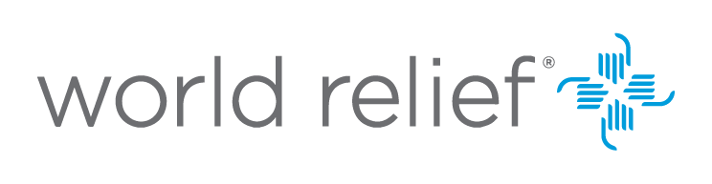
I went back to my hotel lobby and cried. I knew I needed to do more. I imagined that young woman as my 23-year-old self thinking, what if I was in a country where I was separated from my family, didn't know the language, had no money and was trying to take care of my child, wanting them to have a hope and a future?

When we had the idea for PrettyInside, I thought of that woman and wanted to do something that would impact women and children around the world.

Scott: That heart for those who have been traumatized and victimized characterizes so many connected to our work at World Relief. But you took a very specific action. Tell us about that action.
Leisha: I had been familiar with the work of World Relief, but I didn't know specifically the areas ya’ll targeted. As I started looking, I noticed you're one of the foremost organizations addressing the needs [of refugees]. Because this is a beauty brand targeted to women, I wanted to work with somebody that worked a lot with women and children. We saw all the wonderful work y'all were doing, so I just picked up the phone and left a message for one of your staff members, and she immediately called me back.
Scott: If you were sitting with a group of like-minded entrepreneurs who were considering partnering with an organization that could leverage their work to impact the lives of vulnerable people, what would you say to them?
Leisha: In a company you have choices to make about your profits. Isn't it beautiful and more satisfying to be able to use your profits for good? We are given this life, and though we can't change the whole world, we can make an impact on the world right around us.
If we can use at least a portion to give back, that would change the life of another. In my own life, I've learned that when it’s not all about me, that has brought me so much joy. I want both Musee and PrettyInside to be an example of how you can find creative ways to affect change in our culture.
It's been a beautiful opportunity for us to meet y'all and to be encouraged and feel like we're all in this together.

